Home page

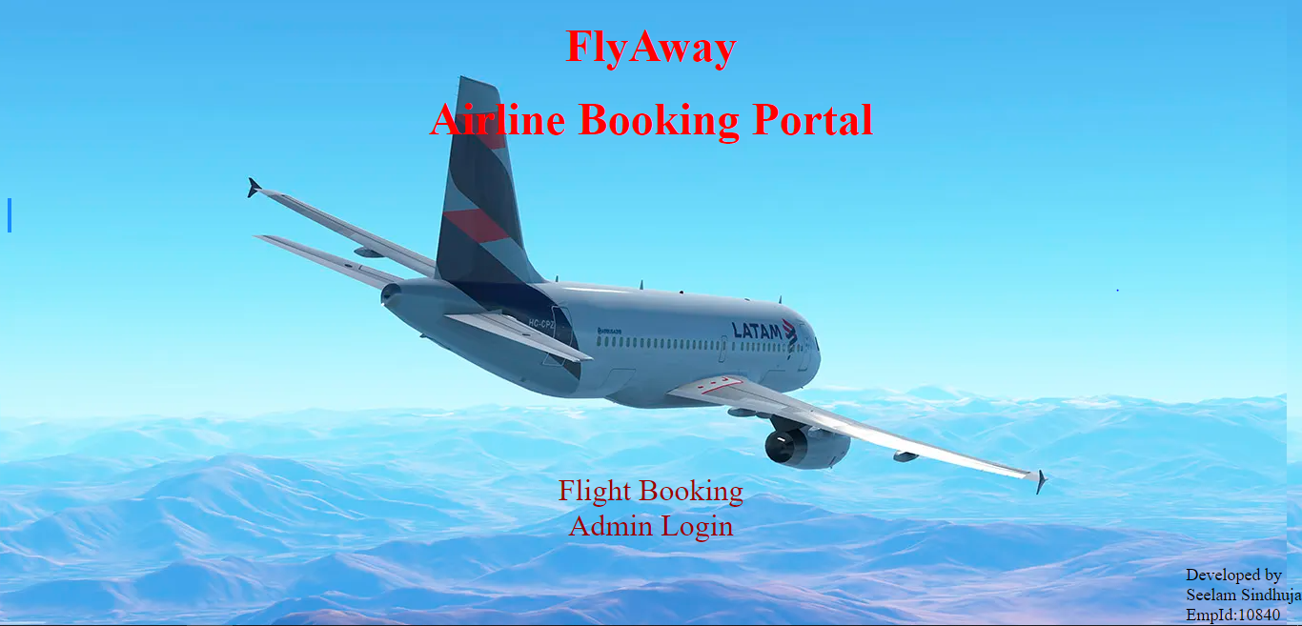

Flight booking page

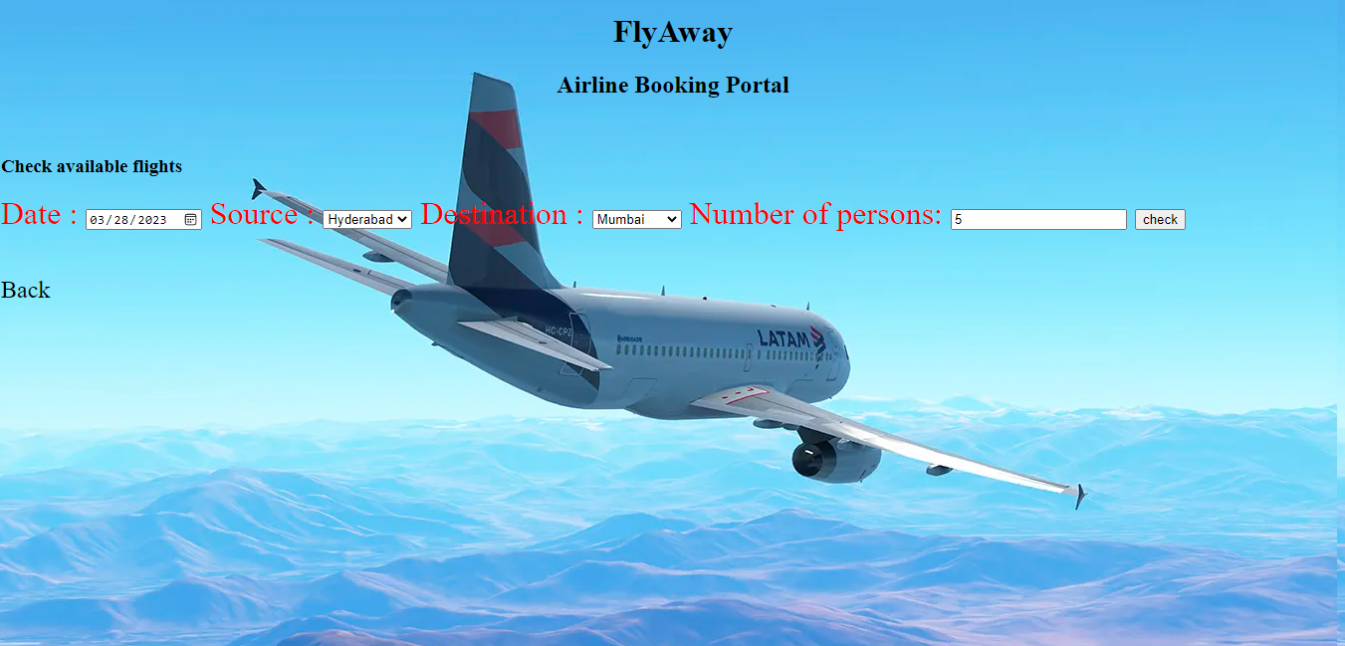

Available Flights

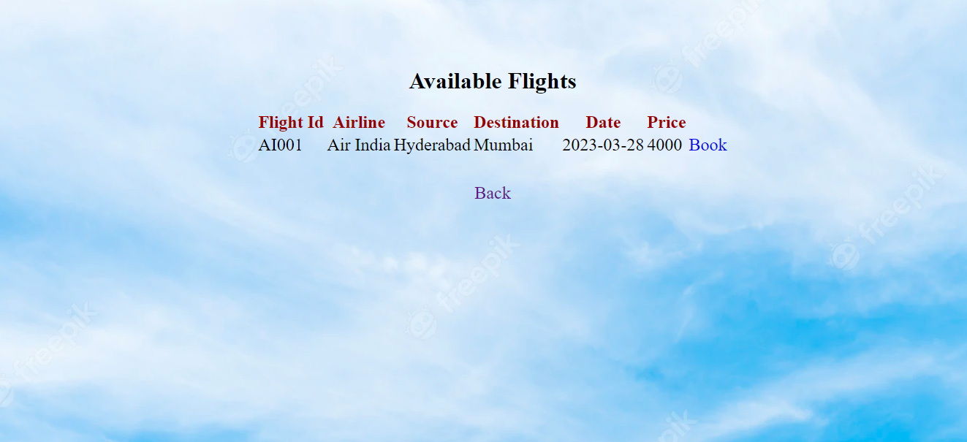

User Registration form

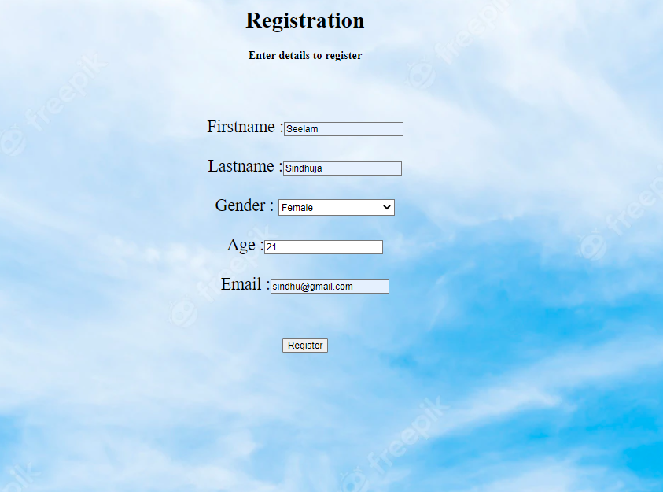

Payment page

Confirmation Page

Admin Login page

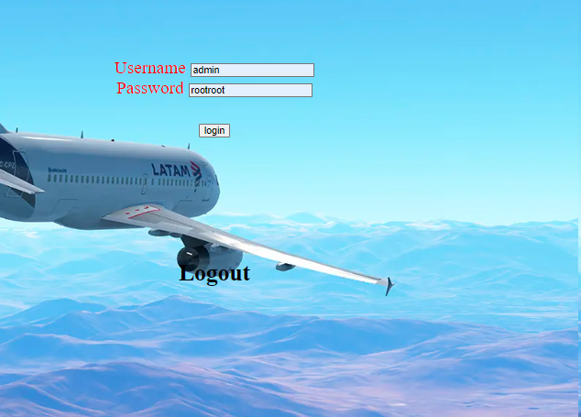

Admin options page

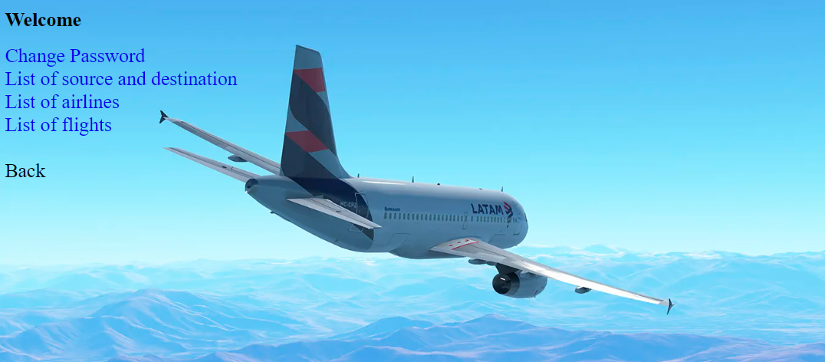

Admin password changing page

Admin airlines list page

Admin source destination list page

Admin flights list page

